WAP to create a file named lab.txt.
66).

#include <iostream>
#include <fstream>
using namespace std;

int main() {
ofstream file("lab.txt");

if (file.fail()) {
cout << "Error creating the file!" << endl;
exit (1);
}
cout << "File created successfully." << endl;
file << "File created successfully." << endl;
file.close();
return 0;
}

- Output:
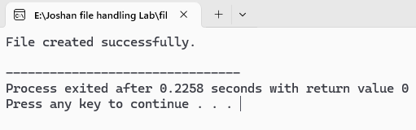

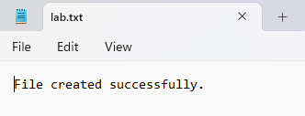

WAP to open above file and write into it.
67).

#include <iostream>
#include <fstream>
using namespace std;

int main() {
ofstream file("lab.txt");
if (file.fail()) {
cout << "Error opening the file!" << endl;
exit (1);
}
file << "Joshan Koirala"<<endl;
file << "BSc. 2nd Sem 2081 Batch \n"<<"Section: A \n"<<"Roll.NO: 09"<<endl;
cout << "Text written to 'lab.txt' successfully." << endl;
file.close();
return 0;
}
- Output:
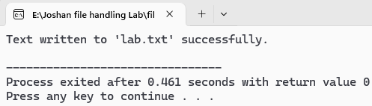

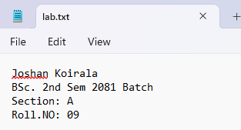

WAP to open above file and write content in append mode.
68).

#include <iostream>
#include <fstream>
using namespace std;

int main() {
ofstream file("lab.txt",ios::app);
if (file.fail()) {
cout << "Error opening the file!" << endl;
exit (1);
}
file <<"Hello!!\n"<<"It's me Joshan Koirala\n"<<endl;
file <<"Opening in append mode"<<endl;
cout << "Text written to 'lab.txt' successfully." << endl;
file.close();
return 0;
}
- Output:
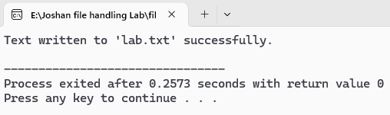
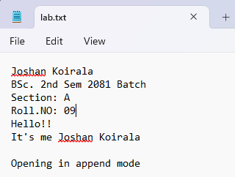

WAP to open lab.txt in read mode and read single line and display in monitor.
69).

#include <iostream>
#include <fstream>
#include <string>
using namespace std;

int main() {
ifstream file("lab.txt", ios::in);
if (file.fail()) {
cout << "Error opening file!" << endl;
exit(1);
}
string str;
if (getline(file, str)) {
cout << "First line in file: \n" << str << endl;
exit(0);
}
file.close();
return 0;
}
- Output:
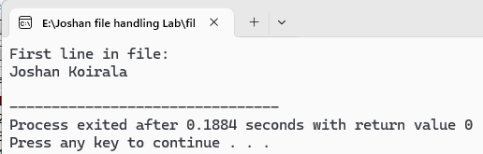

WAP to read whole content of above file and display it.
70).

#include <iostream>
#include <fstream>
#include <string>
using namespace std;

int main() {
ifstream file("lab.txt");
if (file.fail()) {
cout << "Error opening file!" << endl;
exit(1);
}
string str;
cout << "Whole contents of the lab.txt:\n";
while (getline(file, str)) {
cout << str << endl;
}
file.close();
return 0;
}
- Output:
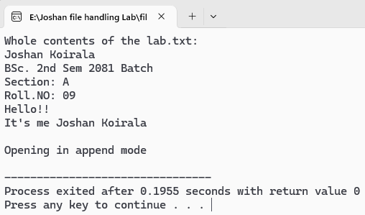

WAP illustrating concept of seekp(), seekg(), tellg(), and tellp().
71).

#include <iostream>
#include <fstream>
#include <string>
using namespace std;
int main() {
fstream file("lab.txt", ios::out | ios::in | ios::trunc);
if (file.fail()) {
cout << "Error opening file!" << endl;
exit(1);
}
file << "Hey\n"<<"World"<<endl;
file << "C++ File Handling\n";
// Showing current write position
cout << "Current write position (tellp): " << file.tellp() << endl;
file.seekp(0, ios::beg); // Moving write pointer to the beginning
file << "MBMC"; // overwrite "Hey"
file.seekg(0, ios::beg); // Move read pointer to the beginning
cout << "Current read position (tellg): " << file.tellg() << endl; // Show current read position
string str;
getline(file, str);
cout << "First line after modification: " << str << endl;
file.seekg(6, ios::cur); // Move read pointer 6 bytes ahead from current position
cout << "Read pointer moved 6 bytes ahead." << endl;
cout << "Current read position (tellg): " << file.tellg() << endl; // Display current read position
file.close();
return 0;
}
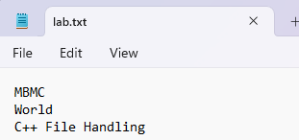
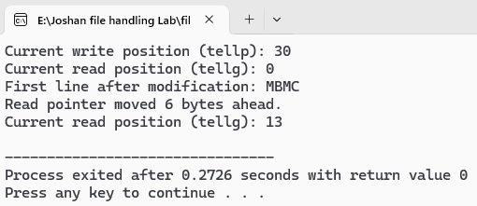
- Output:

WAP that stores information of employees’ class in a file and displays the file content.
72).

#include <iostream>
#include <fstream>
using namespace std;

class Employee {
int id;
char name[50];
double salary;
public:
void input() {
cout << "Enter Employee ID: ";
cin >> id;
cin.ignore(); // clear newline
cout << "Enter Name: ";
cin.getline(name, 50);
cout << "Enter Salary: ";
cin >> salary;
}

void display() const {
cout << "ID: " << id<< " | Name: " << name << " | Salary: " << salary << endl;
}
};

int main() {
Employee emp;
int n;
cout << "Enter number of employees: ";
cin >> n;
ofstream fout("employees.dat", ios::binary);
if (!fout) {
cout << "Error opening file for writing!" << endl;
return 1;
}
for (int i = 0; i < n; i++) {
cout << "\nEnter details of Employee " << i + 1 << ":\n";
emp.input();
fout.write((char*)&emp, sizeof(emp));
}

fout.close();
ifstream fin("employees.dat", ios::binary);
if (!fin) {
cout << "Error opening file for reading!" << endl;
return 1;
}

cout << "\n--- Employee Records from File ---\n";
while (fin.read((char*)&emp, sizeof(emp))) {
emp.display();
}
fin.close();

return 0;
}
- Output:
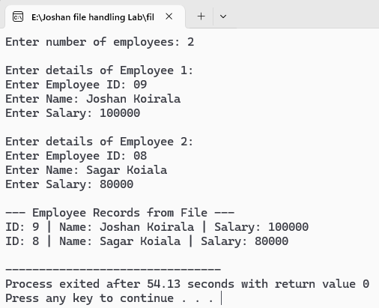

WAP that reads contents of file data.txt and displays content in monitor.
73).

#include <iostream>
#include <fstream>
using namespace std;

int main() {
ifstream file("data.txt");

if (file.fail()) {
cout << "Error opening file!" << endl;
exit(1);
}

string str;
while (getline(file, str)) {
cout << str << endl;
}

file.close();
return 0;
}
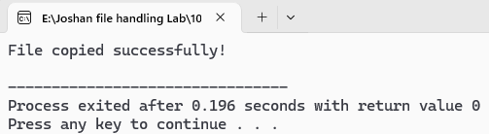
- Output:

WAP to create class named movie with data members name and genre. If the genre of a movie is comedy write it to Comedy.dat and if genre is action , write it to action.dat.
74).

#include <iostream>
#include <fstream>
using namespace std;

class Movie {
public:
string name;
string genre;
void input() {
cout << "Enter movie name: ";
getline(cin, name);
cout << "Enter movie genre: ";
getline(cin, genre);
}

void save() {
if (genre == "comedy" || genre == "Comedy") {
ofstream outFile("Comedy.dat", ios::app);
outFile << name << "," << genre << endl;
outFile.close();
}
else if (genre == "action" || genre == "Action") {
ofstream outFile("Action.dat", ios::app);
outFile << name << "," << genre << endl;
outFile.close();
}
else {
cout << "Genre not recognized. Movie not saved to file." << endl;
}
}
};

int main() {
int n;
cout <<"Enter number of movies : ";
cin >> n;
cin.ignore();

for (int i = 0; i < n; i++) {
Movie m;
m.input();
m.save();
}
cout << "Movies saved based on genre." << endl;
return 0;
}

- Output:
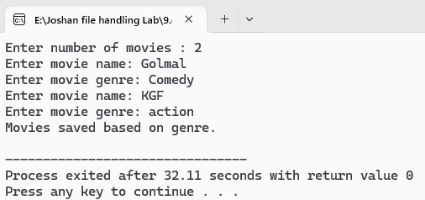
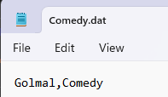
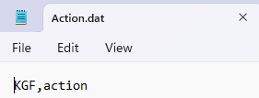

WAP to copy contents of existing file test.txt into another file done.txt.
75).

#include <iostream>
#include <fstream>
using namespace std;

int main() {
ifstream sfile("test.txt");
ofstream dfile("done.txt");
if (sfile.fail()) {
cout << "Error: Could not open source file!" << endl;
exit(1);
}
if (sfile.fail()) {
cout << "Error: Could not create destination file!" << endl;
exit(1);
}
string str;
while (getline(sfile, str)) {
dfile<< str<< endl;
}
cout << "File copied successfully!" << endl;
sfile.close();
dfile.close();
return 0;
}

- Output:
